**Spring Boot Microservices  
A Practical Guide for Beginners**

**I. Introduction**

Microservices architecture has revolutionized how we build modern applications. Instead of building one large monolithic system, we now break it down into smaller, independently deployable services. **Spring Boot** is one of the most popular Java frameworks for building these microservices, thanks to its simplicity, speed, and powerful ecosystem.

In this blog post, we’ll explore:

* **What microservices are**
* **Why Spring Boot is perfect for them**
* **Challenges you may face**
* **Best practices to overcome them**

**II. What Are Microservices?**

Microservices are small, autonomous services that work together to build a complete application.

**Characteristics:**

* Independently deployable
* Loosely coupled
* Technology agnostic
* Scalable and maintainable

📌 *Example:* In an e-commerce app, Order Service, Inventory Service, and Payment Service can all be separate microservices.

**III. Why Use Spring Boot for Microservices?**

Spring Boot simplifies the process of building production-ready microservices. Here’s why it’s a go-to framework:

* ✅ **Auto Configuration**: Reduces boilerplate code
* ✅ **Embedded Servers**: Like Tomcat or Jetty, with no deployment hassle
* ✅ **Spring Cloud Integration**: For service discovery, config, gateway, and fault tolerance
* ✅ **Robust Community Support**: Tons of tutorials, GitHub examples, and StackOverflow threads

**IV. Architecture Overview**

Here's a common Spring Boot microservices architecture:

* 🧭 **API Gateway** – Handles client requests and routes to services
* 🔍 **Eureka Server** – Service discovery
* ⚙️ **Config Server** – Centralized configuration
* 💬 **Feign Clients / REST-Template** – For service communication
* 📊 **Monitoring Tools** – Like Spring Boot Admin, Actuator, Zipkin

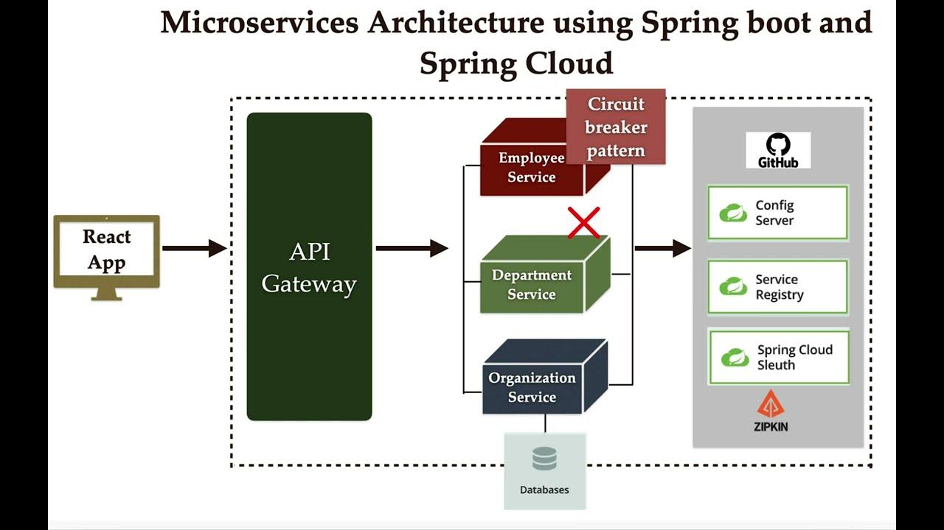

**V. Key Components in Spring Boot Microservices**

**1. Eureka Discovery Server**

Allows microservices to register themselves and discover others.   
**@EnableEurekaServer**  
**@SpringBootApplication**  
**public class DiscoveryServerApplication { }**

**2. Spring Cloud Config Server**Provides external configuration for services.

**3. API Gateway with Spring Cloud Gateway**Routes client requests to the appropriate microservices.

**VI. Challenges in Microservices Development**

**A. Service Communication**

* Complex when services increase
* REST vs gRPC vs Messaging (RabbitMQ/Kafka)

**B. Data Management**

* Each microservice should own its database
* Data consistency is tricky (consider SAGA patterns)

**C. Monitoring & Logging**

* Distributed nature makes tracing issues harder
* Use centralized logging (e.g., ELK stack)

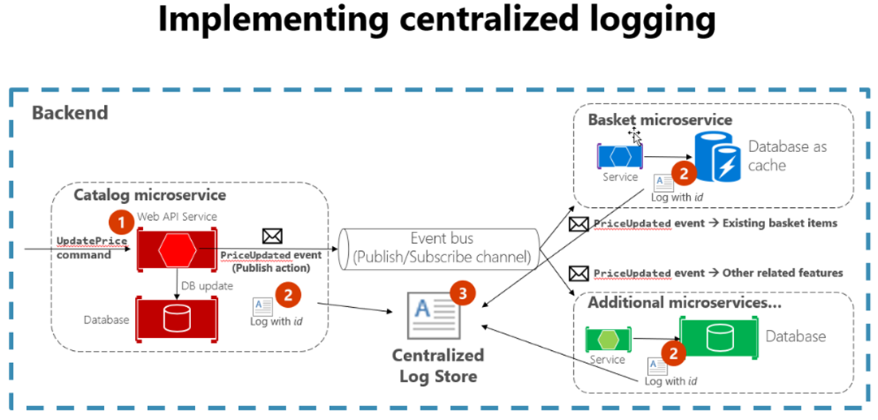

**VII. Best Practices**

* 🧱 **Keep Services Small & Focused**
* 🔗 **Version your APIs**
* 🛡️ **Use Circuit Breakers (e.g., Resilience4J)**
* 🔐 **Secure your APIs with OAuth2/JWT**
* 📦 **Containerize with Docker + Orchestrate using Kubernetes**

**VIII. Sample Use Case: Building a Product Catalog**

* **Product Service** – Manages product data
* **Inventory Service** – Tracks stock
* **Order Service** – Manages orders
* **Communication** – Feign clients or RESTTemplate
* **Database** – Separate DB for each service



**IX. Tools You’ll Need**

* **Spring Boot CLI / Initializr**
* **Spring Cloud**
* **Postman** (for API testing)
* **Docker / Kubernetes**
* **Zipkin / Sleuth** (for tracing)

**X. Resources & Further Learning**

* [Spring Boot Official Docs](https://spring.io/projects/spring-boot)
* [Spring Cloud Docs](https://spring.io/projects/spring-cloud)
* [Baeldung – Spring Boot Tutorials](https://www.baeldung.com/)

**Conclusion**

Spring Boot microservices enable scalable, maintainable systems when designed with care. While the architecture offers flexibility, it also introduces complexity. By leveraging Spring Cloud components and applying best practices, developers can efficiently handle modern enterprise applications.

**Start small, think big, scale gradually.**

**📌 FAQs**

**1. Is Spring Boot suitable for building enterprise-level microservices?**  
Absolutely! It integrates well with Spring Cloud and DevOps tools.

**2. Can I use Spring Boot without Spring Cloud for microservices?**  
Yes, but Spring Cloud makes it significantly easier to manage service discovery, configuration, and routing.

**3. How to handle security in microservices?**  
Use Spring Security with OAuth2 and JWT tokens for securing individual services.

**4. What about communication between services?**  
You can use REST (via FeignClient or REST-Template) or event-driven tools like Kafka.